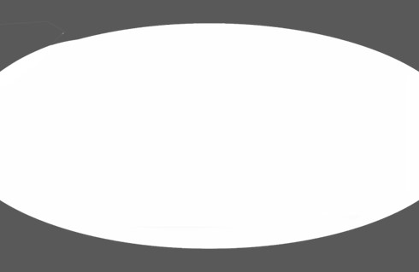
Supplement Sheet

Hereford
Page 1

Lot #/Tag# | 2/21/2026 wt. | SC Circ. | Left eye pigment | Right eye pigment | SC pigment
Lot 30/636M | 1390 | 38cm | 100% | 100% | 100%
Lot 31/637M | 1330 | 38.5cm | 100% | 100% | 100%
Lot 32/639M | 1390 | 38cm | 100% | 100% | 100%
Lot 33/644M | 1300 | 38.5cm | 100% | 100% | 100%
Lot 34/650M | 1255 | 38cm | 100% | 100% | 100%
Lot 35/652M | 1330 | 42cm | 50% | 50% | 100%
Lot 36/653M | 1280 | 37cm | 100% | 100% | 100%
Lot 37/654M | 1250 | 36cm | 80% | 80% | 100%
Lot 38/655M | 1340 | 38cm | 100% | 100% | 100%
Lot 39/659M | 1340 | 39cm | 100% | 100% | 100%
Lot 40/662M | 1370 | 42cm | 80% | 30% | 100%
Lot 41/665M | 1270 | 37cm | 100% | 100% | 100%
Lot 42/666M | 1230 | 40cm | 75% | 75% | 100%
Lot 43/669M | 1360 | 41.5cm | 80% | 100% | 100%
Lot 44/673M | 1460 | 42cm | 100%  goggle | 100%  goggle | 100%
Lot 45/675M | 1340 | 40cm | 100% | 100% | 100%
Lot 46/678M | 1290 | 40cm | 100% | 100% | 100%
Lot 47/682M | 1220 | 38cm | 50% | 100% | 100%
Lot 48/684M | 1300 | 39cm | 100%  goggle | 100%  goggle | 100%
Lot 49/685M | 1270 | 45.5cm | 100% | 100% | 100%
Lot 50/686M | 1230 | 38cm | 100% | 100% | 100%
Lot 51/687M | 1280 | 37cm | 100% | 100% | 100%
Lot 52/699M | 1170 | 37cm | 100%  goggle | 100%  goggle | 100%
Lot 53/269M | 1320 | 41cm | 100% | 0 | 100%
Lot 54/288M | 1215 | 36cm | 100% | 100% | 100%

Page 2

